Math STAAR End Game Planning
5th grade

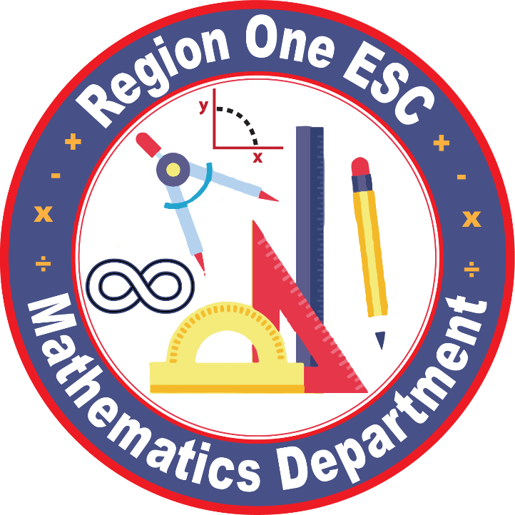

Reporting Category 2
Computations and algebraic relationships

5.3 Numbers and operations. The student applies mathematical process standards to develop and use strategies and methods for positive rational number computations in order to solve problems with efficiency and accuracy. The student is expected to:

- estimate to determine solutions to mathematical and real-world problems involving addition, subtraction, multiplication, or division.

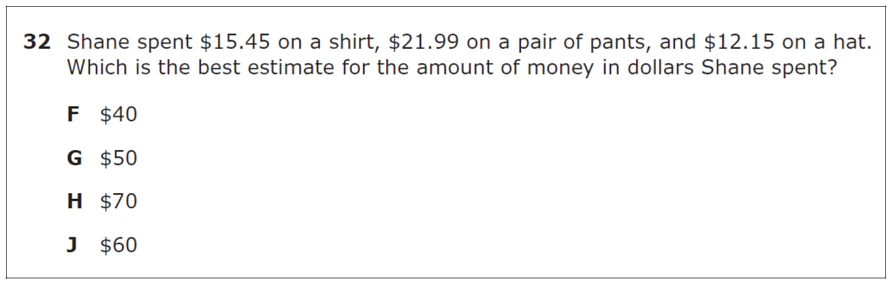Supporting Standard

Answer | State | Region | District
A/F | 13% | 17%
B/G* | 72% | 67%
C/H | 8% | 9%
D/J | 7% | 7%

Vocabulary | Add; Subtract; Multiply; Divide; Rational numbers

Vertical Alignment | 4.4A Add and subtract whole numbers and decimals to the  hundredths place using the standard algorithm.  Readiness Standard

Supporting Information | The word “problems” has been clarified with “mathematical and real-world problems.” Strategies and methods may include front-end estimation (one keeps the first digit of the number and changes all remaining digits to zero), compatible numbers (with values that lend themselves to mental calculations), rounding up or down, and/or compensation (one adjusts estimates to draw closer to an exact calculation). This SE includes estimation with whole numbers, fractions, and decimals. This SE builds on the fourth-grade skills and builds to the grade 6 skill.  .

Allowable supports

Misconceptions

NOTES:

5.3 Number and operations. The student applies mathematical process standards to develop and use strategies and methods for positive rational number computations in order to solve problems with efficiency and accuracy. The student is expected to

B) Multiply with fluency a three-digit number by a two-digit number using the standard algorithm.

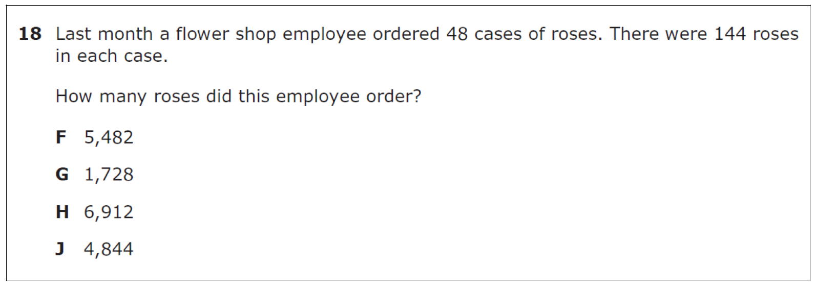
Supporting Standard

Answer | State | Region | District
A/F | 8% | 12%
B/G | 11% | 17%
C/H* | 73% | 59%
D/J | 8% | 12%

Vocabulary | Multiplication; 2 Digit Number, 3 Digit Number; Standard Algorithm

Vertical Alignment | 4.4B Determine products of a number and 10 or 100 using properties of operations and place value understandings.  Supporting Standard

Supporting Information | The introductory paragraph (a)(3) communicates the following: “Students in grade 5 are expected to perform their work without the use of calculators.” When paired with 5(1)(A), the expectation is that students solve real-world problems. Specificity has been provided with the inclusion of the phrase “using the standard algorithm.” Work with the standard algorithm builds on the work from grade 4 with mental math, partial products, and the commutative, associative, and distributive properties for 4(4)(D). The phrase “with fluency” is included. “Procedural fluency refers to knowledge of procedures, knowledge of when and how to use them appropriately, and skill in performing them flexibly, accurately, and efficiently” (National Research Council, 2001, p. 121). This SE builds to the grade 6 skill and eventually to Algebra I [A(10)(B)] as polynomial multiplication can be accomplished using the same algorithm

Allowable supports

Misconceptions

NOTES:

5.3 Number and operations. The student applies mathematical process standards to develop and use strategies and methods for positive rational number computations in order to solve problems with efficiency and accuracy. The student is expected to

C) Solve with proficiency for quotients of up to a four-digit dividend by a two-digit divisor using strategies and the standard algorithm.

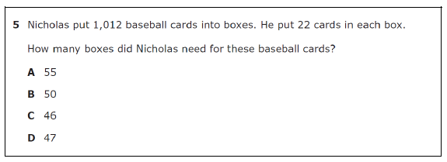
Supporting Standard

Answer | State | Region | District
A/F | 10% | 13%
B/G | 13% | 18%
C/H* | 70% | 61%
D/J | 7% | 8%

Vocabulary | Quotient, digit, dividend, divisor, standard algorithm

Vertical Alignment | 4.4E Represent the quotient of up to a four-digit whole number divided by a one-digit whole number using arrays, area models, or equations.  Supporting Standard  4.4F Use strategies and algorithms, including the standard algorithm, to divide up to a four-digit dividend by a one-digit divisor.  Supporting Standard  4.4H Solve with fluency one- and two-step problems involving multiplication and division, including interpreting remainders.  Readiness Standard

Supporting Information | The introductory paragraph (a)(3) communicates the following: “Students in grade 5 are expected to perform their work without the use of calculators.” When paired with 5(1)(A), the expectations is that students solve real-world problems. Specificity has been provided with the inclusion of the phrase “using strategies and the standard algorithm.” The application of strategies and the standard algorithm includes four-digit dividends. Students are expected to solve with proficiency. Procedural fluency and conceptual understanding weave together to develop mathematical proficiency along with strategic competence, adaptive reasoning, and productive disposition (National Research Council, 2001). “Procedural fluency refers to knowledge of procedures, knowledge of when and how to use them appropriately, and skill in performing them flexibly, accurately, and efficiently” (National Research Council, 2001, p. 121). This SE builds to the grade 6 skill and eventually to A(10)(C) as polynomial division can be accomplished using the same algorithm

Allowable supports

Misconceptions

NOTES:

5.3 Number and operations. The student applies mathematical process standards to develop and use strategies and methods for positive rational number computations in order to solve problems with efficiency and accuracy. The student is expected to

D) Represent multiplication of decimals with product to the hundredths using objects and pictorial models, including area models.

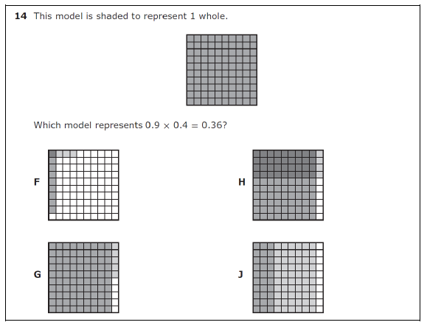
Supporting Standard

Answer | State | Region | District
A/F | 20% | 22%
B/G | 8% | 9%
C/H* | 59% | 53%
D/J | 13% | 16%

Vocabulary | Multiplication, decimal, product, hundredths, area model

Vertical Alignment | No vertical alignment

Supporting Information | The limitation of products to the hundredths constrains the values with which students are asked to work in grade 5. When paired with 5(1)(A), the expectation is that students solve real-world problems. The intent of this SE is not a sole focus on the computation. For example: 0.5 x 3 can be represented using the pictorial model  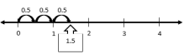  This SE builds to the sixth-grade skill of multiplying and dividing rational numbers fluently.

Allowable supports

Misconceptions

NOTES:

5.3 Number and operations. The student applies mathematical process standards to develop and use strategies and methods for positive rational number computations in order to solve problems with efficiency and accuracy. The student is expected to

E) Solve for products of decimals to the hundredths, including situations involving money, using strategies based on place-value understandings, properties of operations, and the relationship to the multiplication of whole numbers.

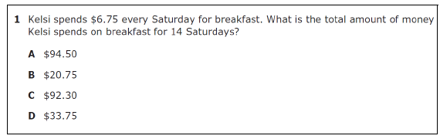
Readiness Standard

Answer | State | Region | District
A/F* | 76% | 64%
B/G | 8% | 13%
C/H | 8% | 12%
D/J | 7% | 10%

Vocabulary | Product, decimal, hundredths, positive rational number, place value, properties, operations, multiplication

Vertical Alignment | No vertical alignment

Supporting Information | Place-value understandings would include estimating factors and products to determine reasonable placement of the decimal in a product. Properties of operations would include thinking with the distributive property. For example, if students are asked to determine the total price of 12 books where each book is $4.50, students might think of this as $4.50 × (10 + 2) and determine $4.50 × 10 is $45 and $4.50 × 2 is $9. $45 and $9 is $54, therefore $4.50 × 12 is $54. The intention is for students to develop flexible thinking with numbers using properties of operations. When paired with 5(1)(A), the expectation is that students solve real-world problems. The intent of this SE is not a sole focus on the computation. Within the TEKS, fluency with decimal multiplication occurs in grade 6

Allowable supports

Misconceptions

NOTES:

5.3 Number and operations. The student applies mathematical process standards to develop and use strategies and methods for positive rational number computations in order to solve problems with efficiency and accuracy. The student is expected to

E) Solve for products of decimals to the hundredths, including situations involving involving money, using strategies based on place-value understandings, properties of operations, and the relationship to the multiplication of whole numbers.

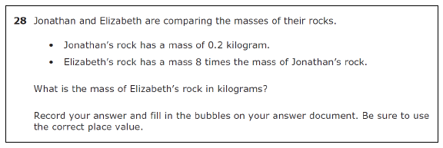
Readiness Standard

Answer | State | Region | District
A/F | 53% | 41%
B/G | 47% | 58%
C/H | 0% | 0%
D/J | 0% | 0%
Grid: 1.6 |  | 41%

NOTES:

5.3 Number and operations. The student applies mathematical process standards to develop and use strategies and methods for positive rational number computations in order to solve problems with efficiency and accuracy. The student is expected to

F) Represent quotients of decimals to the hundredths, up to four-digit dividends and two-digit whole number divisors, using objects and pictorial models, including area models.

ITEM NOT TESTED IN 2021

5.3 Number and operations. The student applies mathematical process standards to develop and use strategies and methods for positive rational number computations in order to solve problems with efficiency and accuracy. The student is expected to

G) Solve for quotients of decimals to the hundredths, up to four digit dividends and two-digit whole number divisors, using strategies and algorithms, including the standard algorithm.

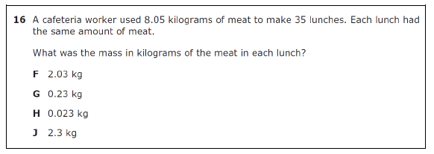
Readiness Standard

Answer | State | Region | District
A/F | 13% | 17%
B/G* | 64% | 56%
C/H | 10% | 11%
D/J | 13% | 15%

Vocabulary | Quotients, decimals, hundredths, four digit dividends, two digit whole number divisors, standard algorithm

Vertical Alignment | No vertical alignment

Supporting Information | Strategies may include mental math, place value, partial products, and properties of operations. The intention is for students to develop flexible thinking with numbers. When paired with 5(1)(A), the expectation is that students solve real-world problems. The intent of this SE is not a sole focus on the computation. Within the TEKS, fluency with decimal division occurs in grade 6. These division skills support the development of computational skills needed for students’ work with division and rates in grade 6 science.

Allowable supports

Misconceptions

NOTES:

5.3 Number and operations. The student applies mathematical process standards to develop and use strategies and methods for positive rational number computations in order to solve problems with efficiency and accuracy. The student is expected to

G) Solve for quotients of decimals to the hundredths, up to four digit dividends and two-digit whole number divisors, using strategies and algorithms, including the standard algorithm.

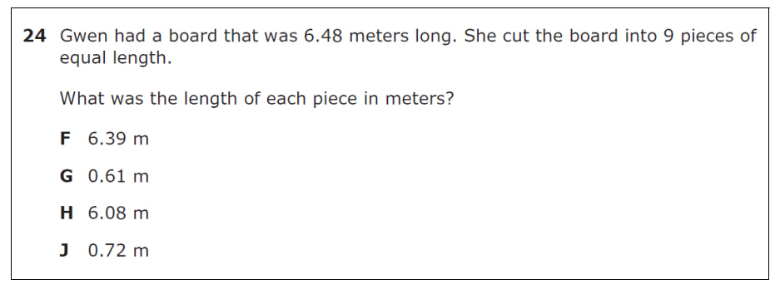
Readiness Standard

Answer | State | Region | District
A/F | 11% | 14%
B/G | 14% | 17%
C/H | 8% | 10%
D/J* | 67% | 58%

NOTES:

5.3 Number and operations. The student applies mathematical process standards to develop and use strategies and methods for positive rational number computations in order to solve problems with efficiency and accuracy. The student is expected to

H) Represent and solve addition and subtraction of fractions
with unequal denominators referring to the same whole using objects and pictorial models and properties of operations.

ITEM NOT TESTED IN 2021

5.3 Number and operations. The student applies mathematical process standards to develop and use strategies and methods for positive rational number computations in order to solve problems with efficiency and accuracy. The student is expected to

I) Represent and solve multiplication of a whole number and a fraction that
refers to the same whole using objects and pictorial models, including area models.

ITEM NOT TESTED IN 2021

5.3 Number and operations. The student applies mathematical process standards to develop and use strategies and methods for positive rational number computations in order to solve problems with efficiency and accuracy. The student is expected to

J) Represent division of a unit fraction by a whole number and the division of a
whole number by a unit fraction such as 1/3 ÷ 7 and 7 ÷ 1/3 using objects and
pictorial models, including area models.

Supporting Standard

Answer | State | Region | District
A/F | 10% | 12%
B/G | 7% | 8%
C/H* | 67% | 62%
D/J | 16% | 18%

Vocabulary | Division, Unit Fraction, Whole Number, Pictorial Model, Area Model

Vertical Alignment | No Vertical Alignment

Supporting Information | When paired with 5(1)(A), the expectation is that students solve problems. The intent of this SE is not a sole focus on the computation. Within the TEKS, fluency with fraction division occurs in grade 6 [6(3)(E)]. A unit fraction is a fraction with a numerator of 1. Students first see unit fractions in grade 3 with 3(3)(C).

Allowable supports

Misconceptions

NOTES:

5.3 Number and operations. The student applies mathematical process standards to develop and use strategies and methods for positive rational number computations in order to solve problems with efficiency and accuracy. The student is expected to

K) Add and subtract positive rational numbers fluently.

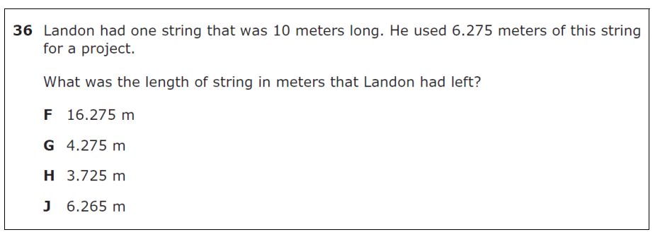
Readiness Standard

Answer | State | Region | District
A/F | 10% | 12%
B/G | 17% | 21%
C/H* | 55% | 47%
D/J | 18% | 20%

NOTES:

5.3 Number and operations. The student applies mathematical process standards to develop and use strategies and methods for positive rational number computations in order to solve problems with efficiency and accuracy. The student is expected to

L) Divide whole numbers by unit fractions and unit fractions by whole numbers
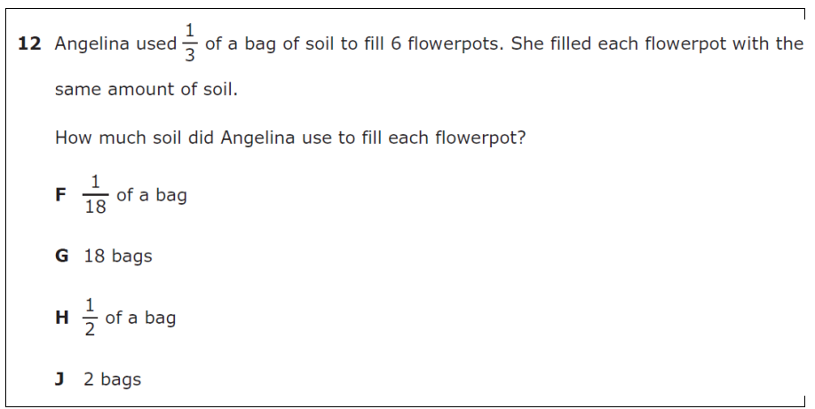
Readiness Standard

Answer | State | Region | District
A/F* | 63% | 52%
B/G | 10% | 12%
C/H | 14% | 22%
D/J | 12% | 13%

Vocabulary | Division, Whole Numbers, Unit Fractions

Vertical Alignment | No vertical alignment

Supporting Information | When paired with 5(1)(A), the expectation is that students solve real-world problems, which involves dividing whole numbers by unit fractions and unit fractions by whole numbers. Within the TEKS, fluency with fraction division occurs in grade 6 [6(3)(E)].

Allowable supports

Misconceptions

NOTES:

5.3 Number and operations. The student applies mathematical process standards to develop and use strategies and methods for positive rational number computations in order to solve problems with efficiency and accuracy.

L) Divide whole numbers by unit fractions and unit fractions by whole numbers
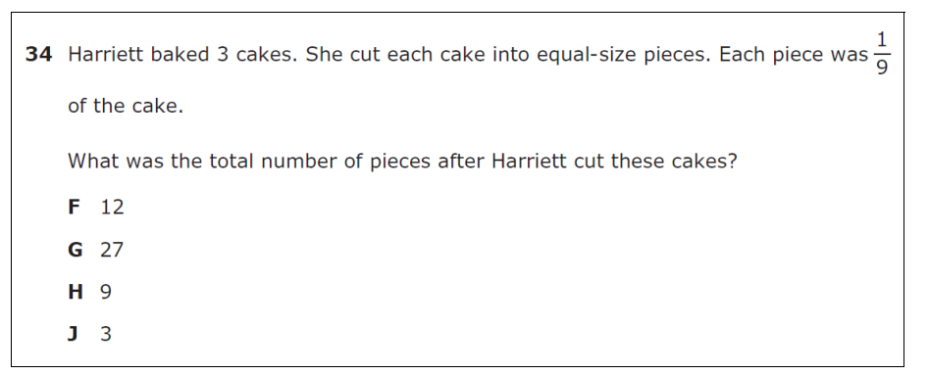

Readiness Standard
Answer | State | Region | District
A/F | 9% | 13%
B/G* | 72% | 65%
C/H | 10% | 14%
D/J | 7% | 8%

NOTES:

5.4 Algebraic Reasoning. The student applies mathematical process standards to develop concepts of expressions and equations. The student is expected to

B) Represent and solve multi-step problems involving the four operations with whole numbers using equations with a letter standing for the unknown quantity.

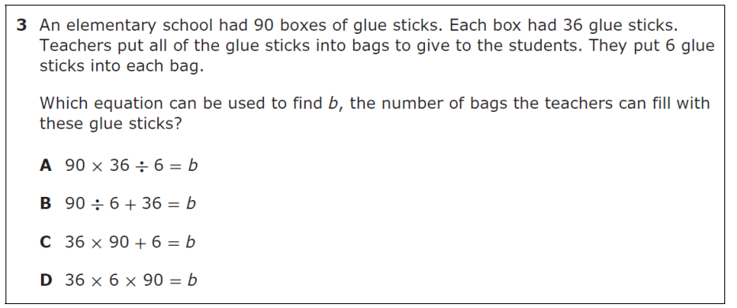
Readiness Standard

Answer | State | Region | District
A/F* | 82% | 77%
B/G | 10% | 11%
C/H | 5% | 7%
D/J | 3% | 5%

Vocabulary | Multi step problem, operations, whole numbers, equations, unknown quantity

Vertical Alignment | 4.5A Represent multi-step problems involving the four operations with whole numbers using strip diagrams and equations with a letter standing for the unknown quantity.  Readiness Standard

Supporting Information | “Multistep problems involving the four operations with whole numbers” includes meaningful problem situations. When paired with 5(1)(D), students may use diagrams, such as strip diagrams, to represent the known and unknown quantities in a multistep problem. The letter standing for the unknown quantity may be any part of the equation. However, students are not expected to solve for a variable that has not been isolated, as those algebraic steps are taught in grades 6 through 8.

Allowable supports

Misconceptions

NOTES:

5.4 Algebraic Reasoning. The student applies mathematical process standards to develop concepts of expressions and equations. The student is expected to

B) Represent and solve multi-step problems involving the four operations with whole numbers using equations with a letter standing for the unknown quantity.

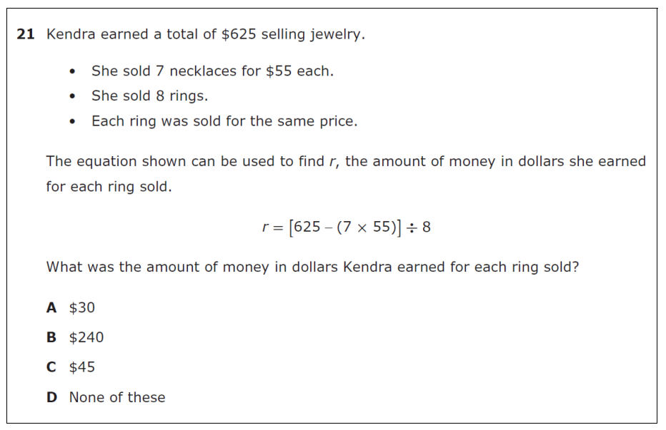
Readiness Standard

Answer | State | Region | District
A/F* | 53% | 42%
B/G | 12% | 16%
C/H | 9% | 13%
D/J | 25% | 28%

NOTES:

5.4 Algebraic Reasoning. The student applies mathematical process standards to develop concepts of expressions and equations. The student is expected to

C) Generate a numerical pattern when given a rule in the form y = ax or
y = x + a and graph.

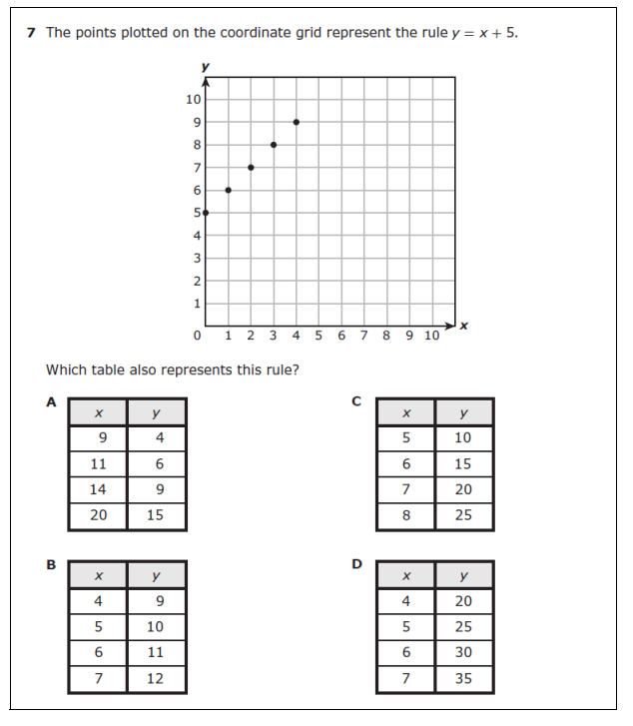
Readiness Standard
Answer | State |  | Region | District
A/F | 7% |  | 8%
B/G* | 70% |  | 67%
C/H | 16% |  | 17%
D/J | 7% |  | 8%
Vocabulary |  | Numerical Pattern, Rule, y = ax, y = x + a, Graph

Vertical Alignment | 4.5B Represent problems using an input-output table and numerical expressions to generate a number pattern that follows a given rule representing the relationship of the values in the resulting sequence and their position in the sequence.  Readiness Standard

Supporting Information | This SE provides clarity for which types of patterns align to grade 5 expectations. This SE refers to patterns that are bivariate (two-variable or input/output) and does not directly refer to sequences.

Allowable supports

Misconceptions

NOTES:

5.4 Algebraic Reasoning. The student applies mathematical process standards to develop concepts of expressions and equations. The student is expected to

C) Generate a numerical pattern when given a rule in the form y = ax or
y = x + a and graph.

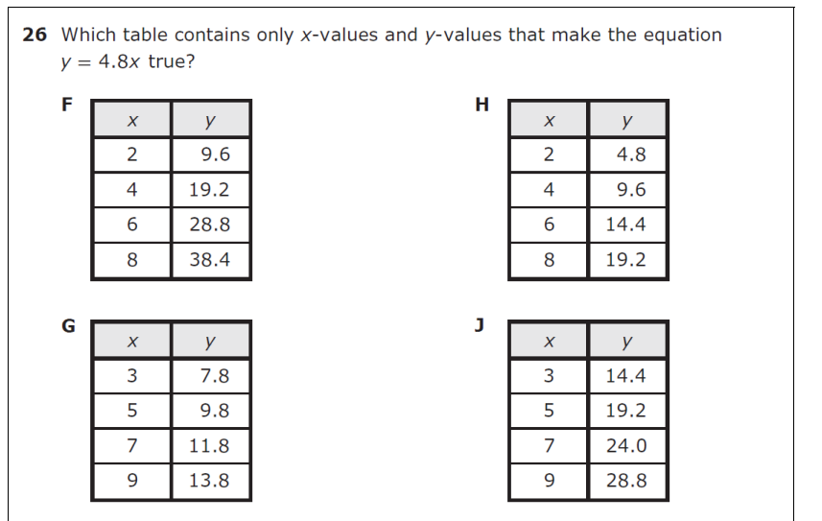

Readiness Standard
Answer | State | Region | District
A/F* | 51% | 46%
B/G | 13% | 15%
C/H | 24% | 26%
D/J | 12% | 13%

NOTES:

